|  |
| --- |
| **[Guide to SIMPLE MAP PRODUCTION]** |
| American Red Cross International Services  http://americanredcross.github.io |

Table of Contents

[Introduction 1](#_Toc367176050)

[Technology Used 1](#_Toc367176051)

[CaerusGeo 1](#_Toc367176052)

[geojson.io 1](#_Toc367176053)

[Inkscape 1](#_Toc367176054)

[Data Export from CaerusGeo 2](#_Toc367176055)

[Using geojson.io 3](#_Toc367176056)

[Viewing Data 3](#_Toc367176057)

[Taking a Screen Grab 5](#_Toc367176058)

[Making a Map in Inkscape 6](#_Toc367176059)

[Set Document Properties 6](#_Toc367176060)

[Paste, Crop, and Resize Your Screen Grab 7](#_Toc367176061)

[Adding a Title and Text 10](#_Toc367176062)

[Adding a Legend 10](#_Toc367176063)

[Adding Custom Icons 10](#_Toc367176064)

[Adding Lines (North Arrow, Leader Lines, Arrows, Horizontal Rules) 11](#_Toc367176065)

[Adjusting Transparency 11](#_Toc367176066)

[Additional Information to Add 12](#_Toc367176067)

[Saving and Exporting Your Map 12](#_Toc367176068)

[Example Map 14](#_Toc367176069)

# Introduction

The Geographic Information Systems (GIS) office at American Red Cross is deeply involved in international disaster response and disaster preparedness programs throughout the world. Accurate and quality surveys to establish baseline and monitoring data allows Red Cross chapters around the world better implement programs. GIS specialists are able to use collected data for map production and advanced analysis. It is likely that volunteers and field staff will be increasingly requested to participate in geospatial data collection. Those people responsible for the data collection should also be able to use it directly instead of having to make all requests through GIS specialists.

This guide provides a simple method for non-technical users to make their own data visualizations and maps. More information and resources can be found at [http://americanredcross.github.io](http://americanredcross.github.io/).

# Technology Used

## CaerusGeo

CaerusGeo (<http://caerusgeo.com>) drastically simplifies GIS data collection for Red Cross projects. Volunteers and staff can create GIS data with nothing more than pen and paper. Users draw important features on paper and note additional attributes on an accompanying spreadsheet; when Red Cross staff later enter data through the simple web interface, it's automatically transformed into usable digital data. The CaerusGeo website provides data visualization but importantly also facilitates data export. In this guide we will cover using data export to combine information from multiple surveys.

## geojson.io

geojson.io (<http://geojson.io>) is a fast, simple, online tool to edit map data.

## Inkscape

Inkscape is an open source graphics editor. We will use it to create our map by adding a title, legend, custom markers, and other features. Download the program. Go to <http://inkscape.org/download/> and under ‘Official Release Packages’ choose appropriate file. You will probably want the Windows installer. Follow the instructions to install the program to your computer.

# C:\Users\GIS3\Documents\GitHub\Guides\SimplestMapProduction\img\CaerusGeo_VolunteerLocations.pngData Export from CaerusGeo

This guide assumes that you have already completed survey(s) using CaerusGeo. In this survey we will use fake data for volunteer locations, emergency shelter locations, and landslide hazard zones. For each survey with data you want to include on your map:

* Navigate to the ‘Reports’ tab
* Click ‘Result Exports’
* 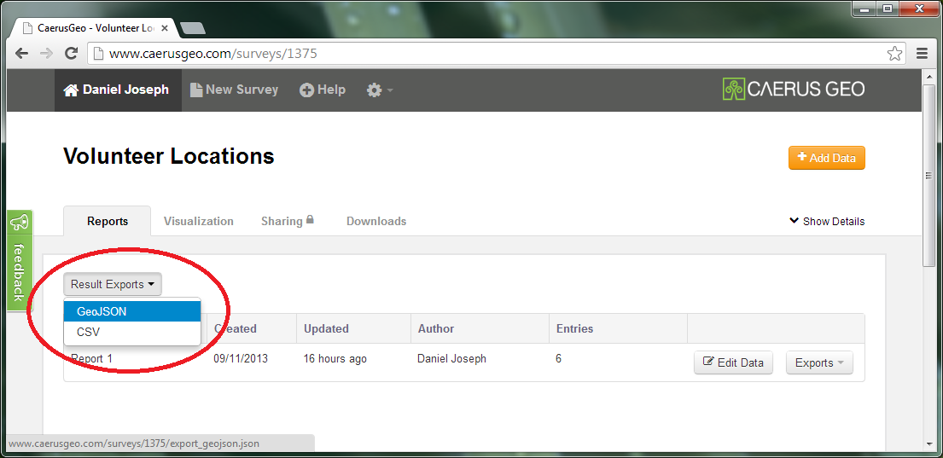Choose the GeoJSON option
* Save the file to your computer

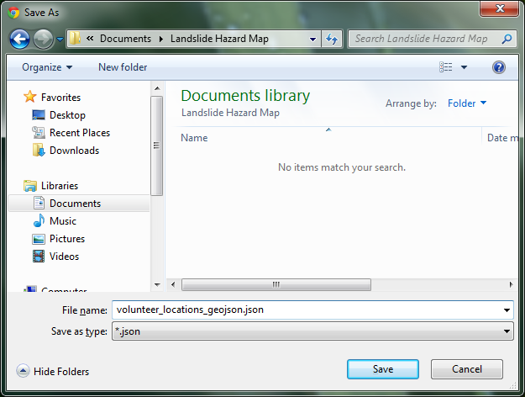

**Note:** The survey name is used for the file name and should be descriptive. You can change the file name if necessary, but don’t change the file type. It is a good idea to make a new folder for a map project and to save all your data files to it.

# Using geojson.io

## Viewing Data

Open up your web browser and navigate to <http://geojson.io>

1. Click the file folder for the ‘Open’ data options
2. Click the Import option
3. Browse to the project data files downloaded from CaerusGeo and open one

Repeat the above steps for each data file you want to add to your map.

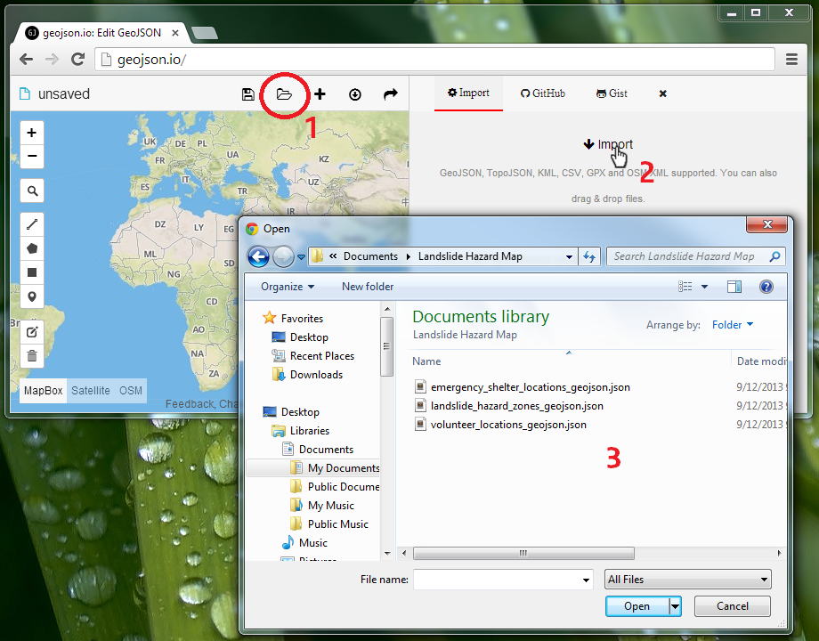

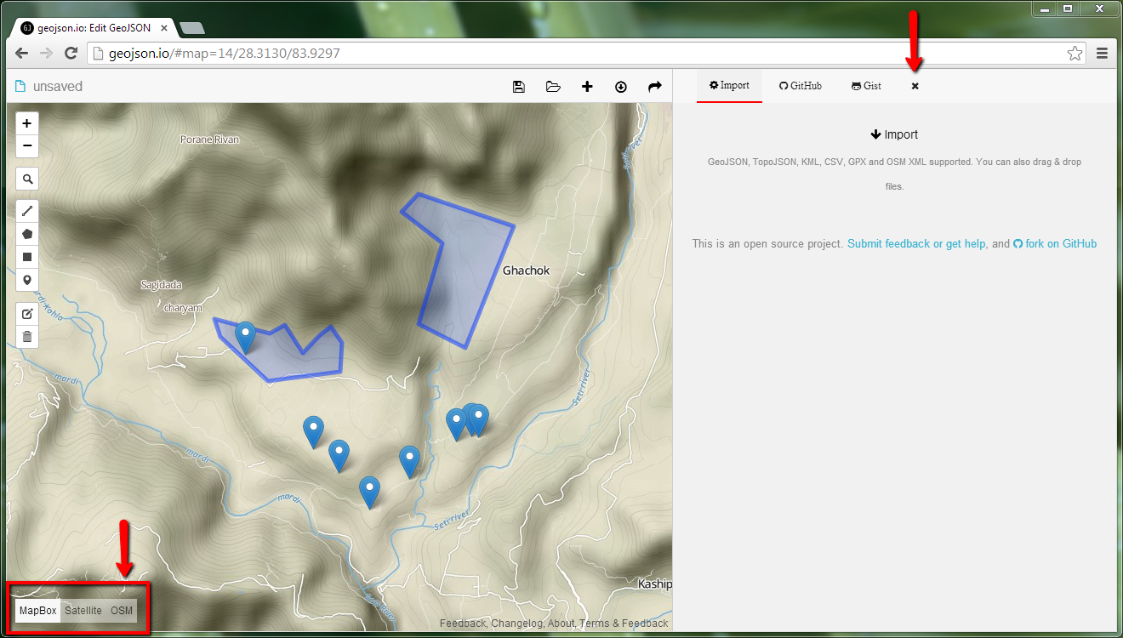

* Click the small ‘x’ above the import section to display the Table information for your data
  + The answer fields and feature attributes will display
* Change the background layer using the three options in the lower-left corner of the map

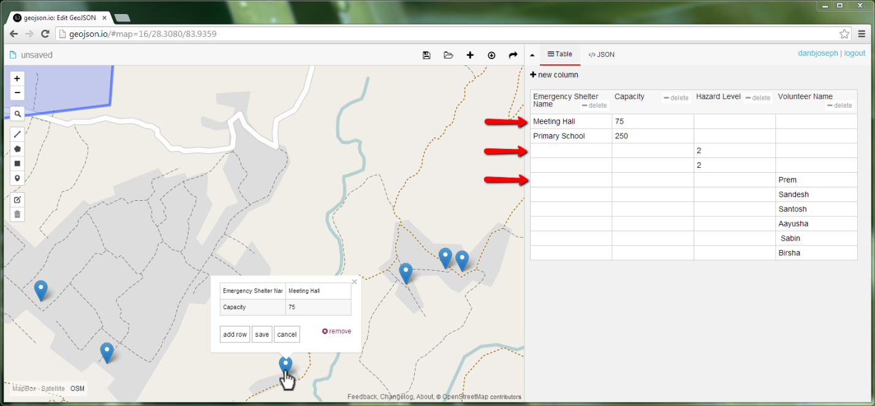

* ‘MapBox’ and ‘OSM’ are based on the same data and look most like a traditional paper map but will display slightly different selections of the data and with different symbology
* ‘Satellite’ will have most roads marked on top of a satellite imagery layer
* Each data feature will display in the Table as a single row

## Taking a Screen Grab

You want to capture an image of your map that you can open in Inkscape, a graphics editing program.

* Maximize your web browser window so that it fills your entire screen

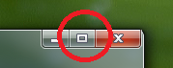

* Click the up arrow above the Table information to collapse the side menu and view only the map

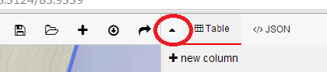

* Adjust the map view so the entire area for your map is visible on the screen
  + Zoom using the + and – buttons in the top left of the map, double-left-click the map, or use the scroll wheel on your mouse
  + Left click, hold, and drag to pan the map
* Press the ‘Print Screen’ key on your keyboard to copy the screen image to the computer’s memory

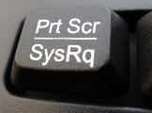

# Making a Map in Inkscape

## Set Document Properties

* Open Inkscape
* From the ‘File’ menu select ‘Document Properties’ to open an options box

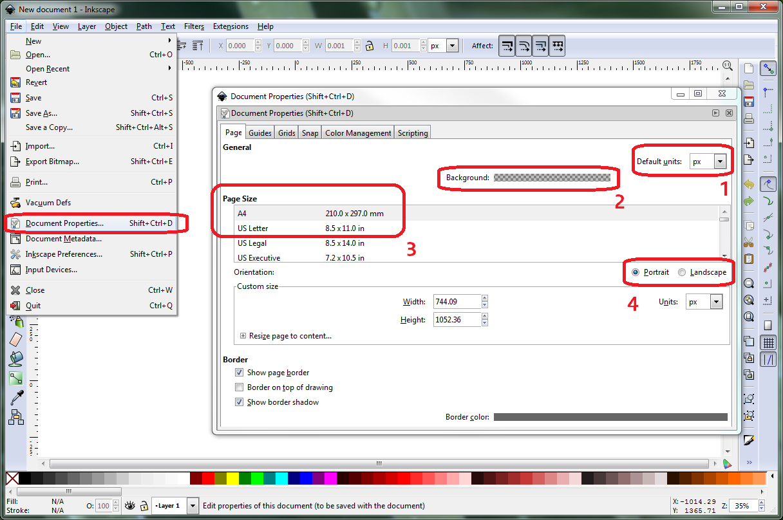

* Set the ‘Default units’ (1) to either ‘in’ for inches or ‘cm’ for centimeters
  + This will change the units of the rulers along the top and left side of the screen
* Click the checkered bar next to ‘Background’ (2) and set the background color to white by changing all four values to 255

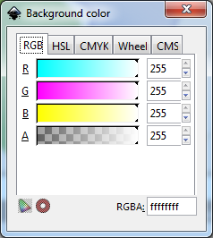

* Choose a ‘Page Size’ (3) according to what size you will be printing your map
* Choose either ‘Portrait’ or ‘Landscape’ for ‘Orientation’ (4)
* Close the options box

## Paste, Crop, and Resize Your Screen Grab

* You should have taken a screen grab from geojson.io before opening Inkscape
* Edit, Paste
* Left click, hold, and drag to center of screen
* Click the ‘Create rectangles and square’ button in the left side menu

C:\Users\GIS3\Documents\GitHub\Guides\SimplestMapProduction\img\inkscape_RectangleTool.png

* Click the red X in a white box in the lower left corner of the screen to create a rectangle with no background color

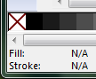

* Left click and hold on your pasted screen grab at the top left corner of the area you want to include on your map
* Drag to the bottom right corner of the area you want to include and release
  + There should be a rectangle around the area you want to include and a dotted line indicating that the rectangle is selected

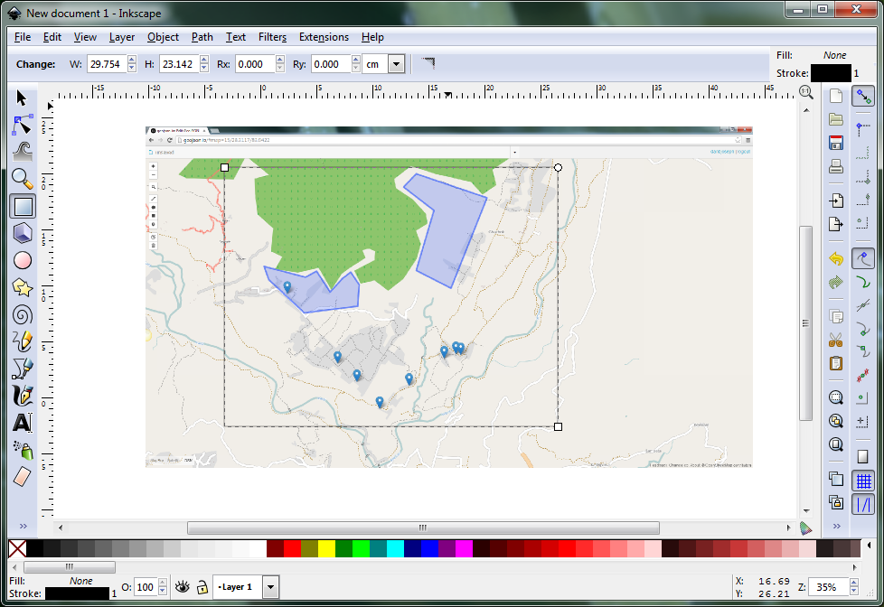

* Hold the Shift key and left click the pasted screen grab outside of the rectangle
  + Now there should be a dotted line along the rectangle border and around the outside of your screen grab
* From the ‘Object’ menu select ‘Clip’ and ‘Set’
  + Only the area of the screen grab that was inside of the rectangle should be displayed
* Click the ‘Select and transform objects’ button on the left side menu

C:\Users\GIS3\Documents\GitHub\Guides\SimplestMapProduction\img\inkscape_SelectButton.png

* From the top tool bar click the open lock button
  + It will change to a closed lock and when you change the size of the image the proportion will remain the same

C:\Users\GIS3\Documents\GitHub\Guides\SimplestMapProduction\img\inkscape_LockAspect.png C:\Users\GIS3\Documents\GitHub\Guides\SimplestMapProduction\img\inkscape_LockedAspect.png

* Resize the image to fit within the bounds of your page
  + Left click inside the image, hold, and drag to reposition the image
  + Left click any of the diagonal arrow icons at the corners, hold, and drag to enlarge or shrink the image
* Zoom to fit the page to you screen
* From the ‘View’ menu select ‘Zoom’ and ‘Page’

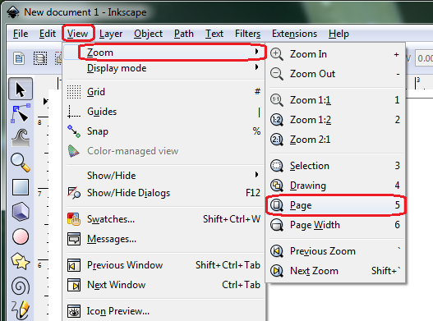

* It is a good idea to regularly save your work
  + From the ‘File’ menu select ‘Save’
  + Browse to your project folder
  + Change the ‘File name’ to something descriptive
  + Leave the file type as ‘Inkscape SVG (\*.svg)’

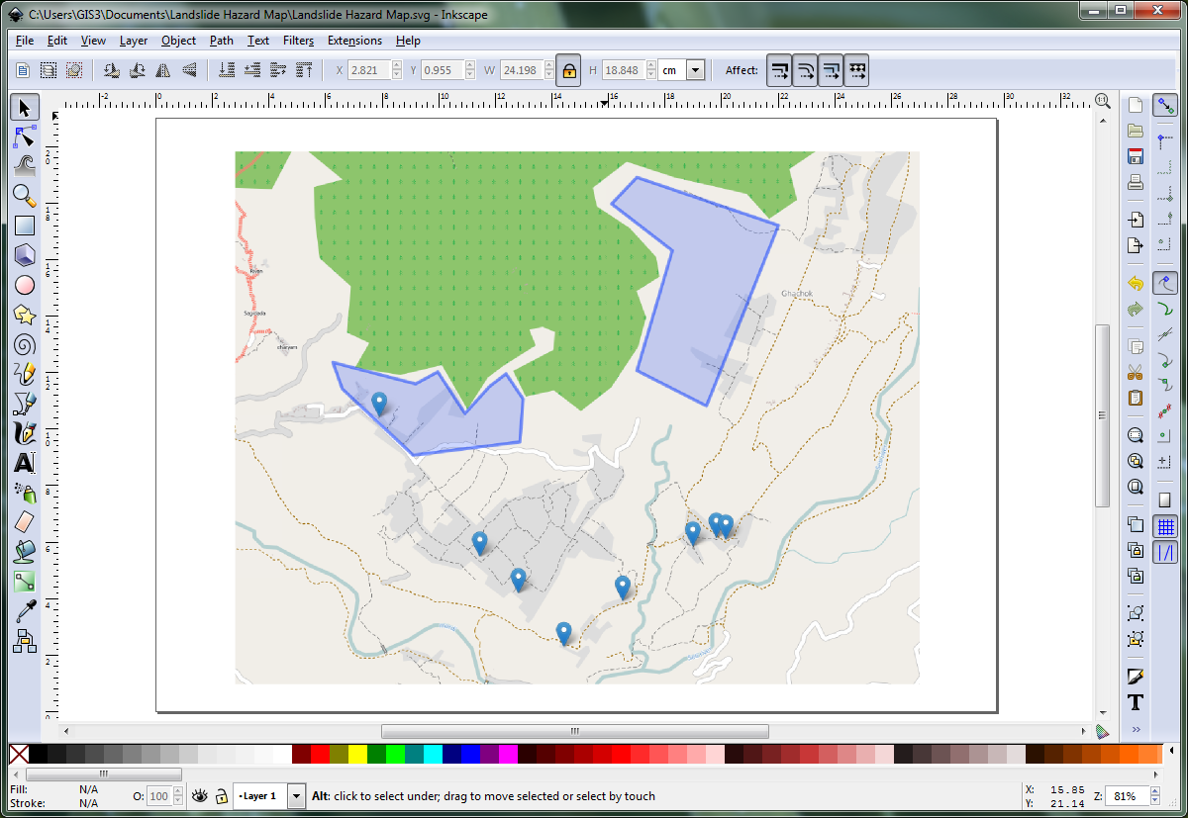

* You’re ready to start adding additional elements to your map!

## Adding a Title and Text

* Click the ‘Create and edit text objects’ in the left side menu

C:\Users\GIS3\Documents\GitHub\Guides\SimplestMapProduction\img\inkscape_AddTextButton.png

* Left click on the page where you want you title text to start, a blinking position line should appear, type your title
* Left click the title, hold, and drag to reposition it on the page
* Double left click and select all the text then use the options in the top options bar to adjust the font family, size, weight (bold), and style (italic)

C:\Users\GIS3\Documents\GitHub\Guides\SimplestMapProduction\img\inkscape_FontOptions.png

* You can add other text to your map using the same steps as when adding a title
* To change the color of text use the bottom color bar

C:\Users\GIS3\Documents\GitHub\Guides\SimplestMapProduction\img\inkscape_ColorBar.png

## Adding a Legend

* Click the ‘Create rectangles and square’ button in the left side menu (the same one you used to crop your screen grab)
* Left click the bottom color bar to choose the fill color
* Hold Shift and left click the bottom bar to choose the stroke (border) color
* Look at the top right corner of the window to check your selection

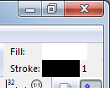

* Create a box on your page
* Follow the instructions for adding text to add the names for each of your map features

## Adding Custom Icons

* You can use icons saved from the internet, the UN OCHA icons available for download alongside this exercise or at <http://reliefweb.int/map/world/world-humanitarian-and-country-icons-2012>
* Once an icon is saved to your computer, open the containing folder next to the Inkscape window, drag and drop the file icon into your map in Inkscape, choose to ‘embed’ the image

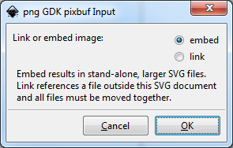

* After selecting an icon use the aspect ratio lock option in the top tool bar to keep the height and width equal when resizing using a corner arrow

C:\Users\GIS3\Documents\GitHub\Guides\SimplestMapProduction\img\inkscape_LockAspect.png C:\Users\GIS3\Documents\GitHub\Guides\SimplestMapProduction\img\inkscape_LockedAspect.png

* If resizing an icon for use multiple times on the same map, resize once and then copy and paste within Inkscape
  + If you drag, drop, and embed the image each time you want to use it, you will have to resize it every time
* You can left click, hold, and drag to reposition added icons

## Adding Lines (North Arrow, Leader Lines, Arrows, Horizontal Rules)

* Click the ‘Draw Bezier curves and straight lines’ button in the left side menu

C:\Users\GIS3\Documents\GitHub\Guides\SimplestMapProduction\img\inkscape_LineTool.png

* Left click at the start point of your line, left click at the end point of your line, then press Enter
  + It is easy to make a horizontal or vertical line if you hold Ctrl when placing the end point, the line will snap to 15O  angle increments (0O will be horizontal and 90O will be vertical) 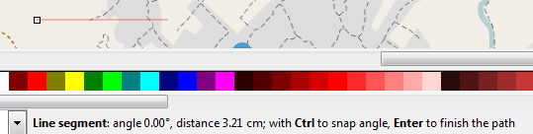
* From the ‘Object’ menu select ‘Fill and stroke…’ to open a side bar menu
* Select your line segment, and then select the ‘Stroke style’ tab from the side bar menu
  + Use ‘Width’ to adjust the thickness of the line
  + Use ‘Cap’ to change the end style (you can round the ends of your line)
  + Explore the other options
* To change the color you need to select the line segment and then hold shift while selecting from the bottom color bar

**Note:** You can use multiple lines to add a north arrow to your map, and then use the text tool to add an ‘N’ or the word ‘North’

**Note:** Some of the things you can use lines for include formatting your legend, underlining your map title, and connecting a label to point on the map

## Adjusting Transparency

* You can adjust the transparency of items you’ve added to the map
* From the ‘Object’ menu select ‘Fill and stroke…’ to open a side bar menu
* Select an element and use the ‘Opacity, %’ slider bar to adjust the transparency
  + If changing the body color of a rectangle adjust the option on the ‘Fill’ tab
  + If changing a border or line adjust the option on the ‘Stroke style’ tab
  + 0% is completely clear and 100% is completely solid or opaque

**Note:** If text or a title is positioned over the map and hard to read, but you don’t want to completely hide the map, try adding a mostly transparent white rectangle as a backdrop to the text

## Additional Information to Add

* Your map should generally have a title and legend
* A north arrow will help orient users
* It is a good idea to add small text that provides information regarding the creation of the map
  + Provide the source of the data and base layer
  + Provide a date of creation
  + Provide the name of the person who created the map

## Saving and Exporting Your Map

* When you save your project it saves as a \*.svg file
  + This file format keeps your added elements separate and allows you to continue to edit each individual item separately
  + This file format is not great for sharing your map
* When your map is finalized and you are ready to share and print, save the project a final time
  + From the ‘File’ menu select ‘Export Bitmap…’
  + For ‘Export Area’ choose ‘Page’
    - This will set the boundaries of the exported image to the page boundaries visible in your Inkscape project
  + For the ‘FileName’ select ‘Browse…’ and navigate to the desired folder on your computer
    - The default file name will be the same as your project file but will a \*.png extension instead of a \*.svg extension
    - You can change the filename
  + Click ‘Export’
  + You can close the ‘Export Bitmap’ window and your project
  + Navigate to the folder on your computer and view your files
  + You can add the \*.png copy of your map to a Microsoft Word document, print from the option menu that opens when you right click the file, or open it in a program like Microsoft paint in order to print it

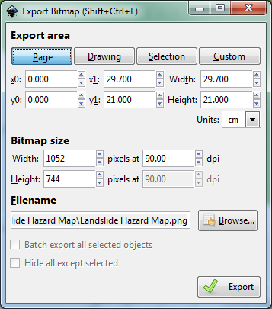

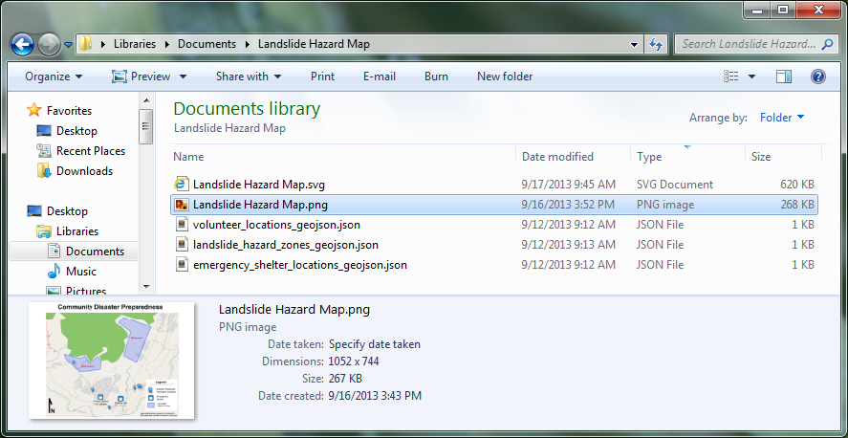

Example Map

